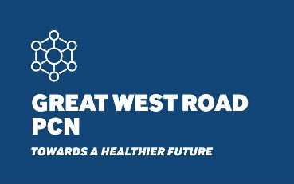

Great West Road PCN Privacy Notice

1 December 2021
Great West Road (GWR) PCN was formed in July 2019. It now comprises of 9 GP practices across the Great West Road locality in Hounslow and serves a combined area of 68,000 patients.
Members of the network are:
- Clifford Road Surgery
- Cranford Medical Centre
- Crosslands Surgery
- Dr Sood's Surgery
- Healthy in Your Own Skin (HIYOS)
- HMC Health Heston
- Jersey Practice
- Skyways Medical Centre
- The Medical Centre

By operating as a network, we are able to provide a more comprehensive set of services, provided by local clinicians and healthcare providers.

These services currently include:
- GP and Primary Care Specialist Services
- Covid Vaccination Programme
- Covid Vaccination Home Visiting Service
- First Contact Physiotherapy
- Structured Medication Reviews
- Social Prescribing Services

Where necessary and relevant to support the direct care of our patient population, we may share your confidential patient information with members of our network to support your safe, efficient and effective care and treatment.

How we use your information
To enable us to be able to provide the additional Primary Care Specialist Services and tailor your treatment we sometimes need to share data from your GP health record with the other organisations involved in the delivery of these. This includes:
- Other GP Practices within the PCN – which may employ staff involved in delivering the services
- Healthcare Assistants, Physician Associates, Clinical Pharmacists, Paramedics, Physiotherapists and Social Prescribers all of whom work together with us to deliver the PCN services

We will only share identifiable data about you with organisations that could be involved in determining and/or providing your care and treatment. Your data will only be shared with health and social care professionals who are working under a contractual duty of confidentiality.
We will use data which you cannot be identified from when we are undertaking the planning and commissioning of local health and care services. This ‘de-identified data’ is effectively anonymised in accordance with the Information Commissioner’s Office Code of Practice, a summary of which is available at ico.org.uk/anonymisation_code_summary (PDF).

How you can object to the way we use information
If you are not happy for your health data to be shared with the organisations detailed above, then you can object to this. To do so you should contact your registered GP Practice so they can discuss the potential impact this could have on your care and treatment.
If you do not wish for your de-identified data to be used for planning and commissioning of PCN services you are able to opt-out of this via the National Opt-Out – please see the NHs website for further details: www.nhs.uk/your-nhs-data-matters

Please contact the GWR PCN Support Manager, Sanam Dhaliwal at sanam.dhaliwal@nhs.net should you require further information about our PCN services.

